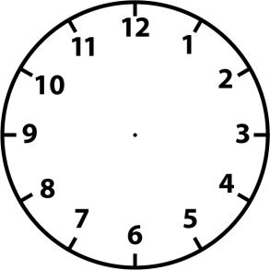
What time is it?

__________________ ____________________

__________________ _____________________

__________________ ______________________

What time is it?

__________________ ____________________

__________________ _____________________

__________________ ______________________

