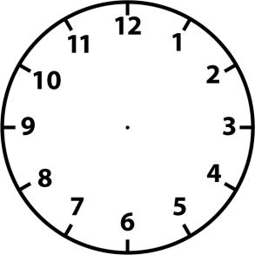
What time is it?

It’s quarter to eleven. It’s half past five.

It’s seven o’clock. It’s quarter past one.

It’s half past three. It’s quarter to six.

What time is it?

It’s quarter to eleven. It’s half past five.

It’s seven o’clock. It’s quarter past one.

It’s half past three. It’s quarter to six.

