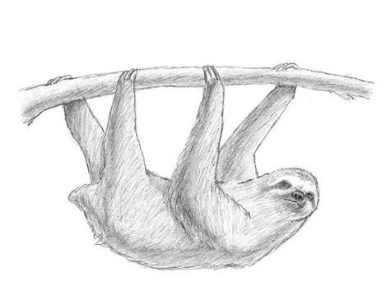
Dejte slovesa do správného tvaru.
1) My favourite animal ______ (be) the sloth.
2) It _________ (live) in the trees of tropical forests.
3) ______ it ________ (eat) meat? - No, it _______.
4) It _________ (eat) leaves.
5) It _________ (have got) very long arms and legs.
6) It _________ (live) in a hot place.

Dejte slovesa do správného tvaru.
1) My favourite animal ______ (be) the sloth.
2) It _________ (live) in the trees of tropical forests.
3) ______ it ________ (eat) meat? - No, it _______.
4) It _________ (eat) leaves.
5) It _________ (have got) very long arms and legs.
6) It _________ (live) in a hot place.

Dejte slovesa do správného tvaru.
1) My favourite animal ______ (be) the sloth.
2) It _________ (live) in the trees of tropical forests.
3) ______ it ________ (eat) meat? - No, it _______.
4) It _________ (eat) leaves.
5) It _________ (have got) very long arms and legs.
6) It _________ (live) in a hot place.

