**Odpovězte na otázky podle vzoru.**

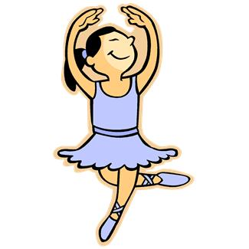 Is he drinking? Is she dancing?

No, he isn’t. Yes, she is.

He is eating. ________________________

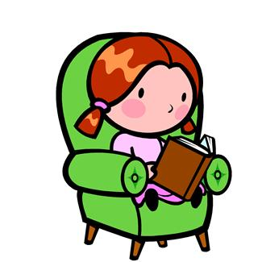

Is he sleeping? Is she writing?

___________ ____________

____________________ _________________________

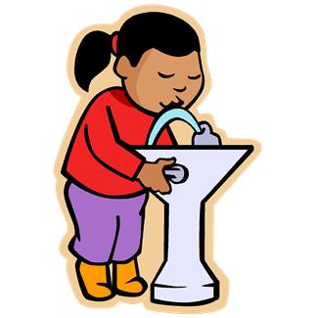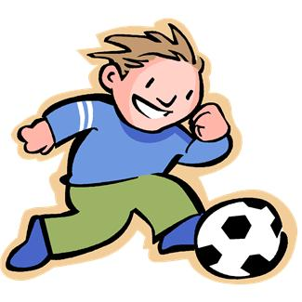 Is she drinking? Is he playing tennis?

_____________ _______________

______________________ __________________________

**Odpovězte na otázky podle vzoru.**

 Is he drinking? Is she dancing?

No, he isn’t. Yes, she is.

He is eating. ________________________



Is he sleeping? Is she writing?

___________ ____________

____________________ _________________________

 Is she drinking? Is he playing tennis?

_____________ _______________

______________________ __________________________