Rain Rain
Rain rain Sun sun
falls on the street, is breaking through,
mud in puddles clouds are moving,
cleaning my feet. the rain stops too.
Thunder thunder Rainbow rainbow
rumble and roar, across the sky,
close the windows see-through colours
and lock the door. to tickle my eyes.
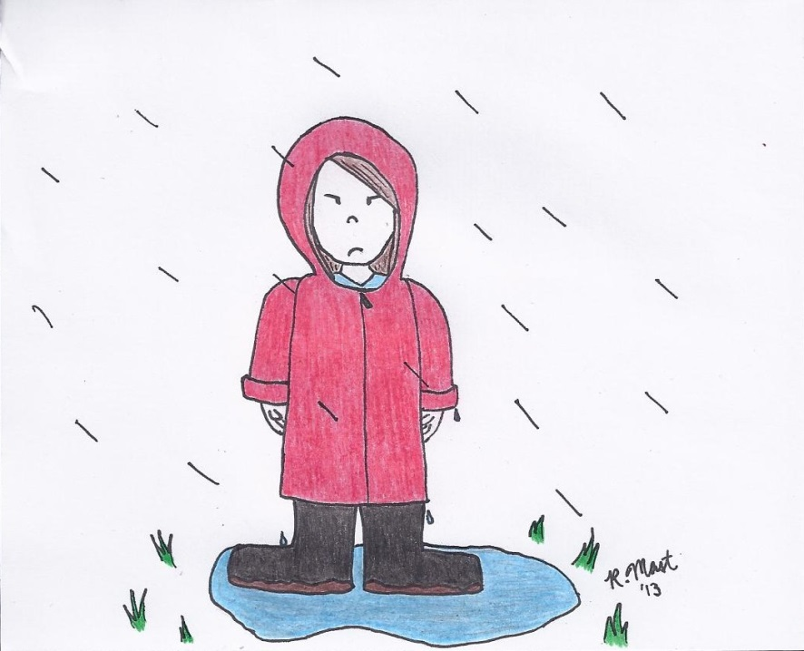
Clouds clouds
black and gray,
heavy with water
to drop all day.

Rain Rain
Rain rain Sun sun
falls on the street, is breaking through,
mud in puddles clouds are moving,
cleaning my feet. the rain stops too.
Thunder thunder Rainbow rainbow
rumble and roar, across the sky,
close the windows see-through colours
and lock the door. to tickle my eyes.
Clouds clouds
black and gray,
heavy with water
to drop all day.

