Doplň krátké odpovědi.
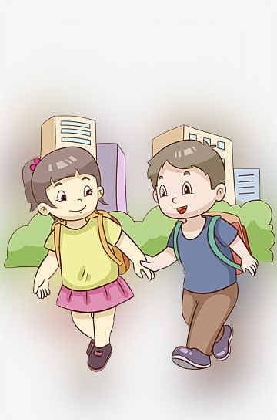
1) Have you got a brother? _________________
2) Are you hungry? _________________
3) Have you got an apple in your bag? _________________
4) Is it cold outside? _________________
5) Have you got a pet? _________________
6) Are you a girl? _________________
7) Have you got blue eyes? _________________
8) Is your school big? _________________
9) Has it got three floors? _________________
10) Are you eight years old? _________________

Doplň krátké odpovědi.
1) Have you got a brother? _________________
2) Are you hungry? _________________
3) Have you got an apple in your bag? _________________
4) Is it cold outside? _________________
5) Have you got a pet? _________________
6) Are you a girl? _________________
7) Have you got blue eyes? _________________
8) Is your school big? _________________
9) Has it got three floors? _________________
10) Are you eight years old? _________________

