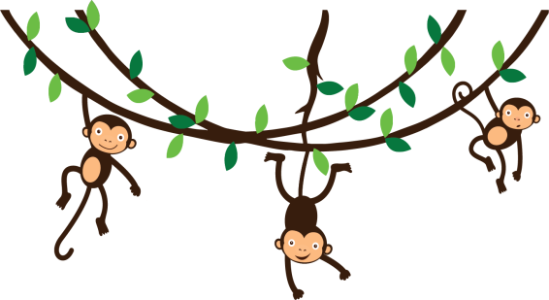
Napiš 4 věty o obrázku. Použij There is, there are …
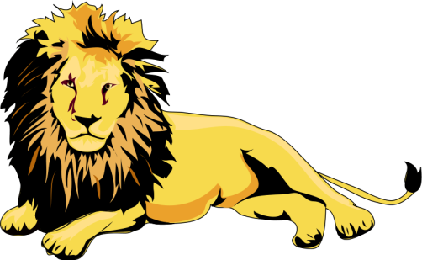
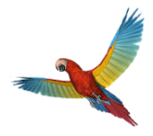
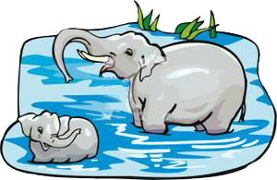
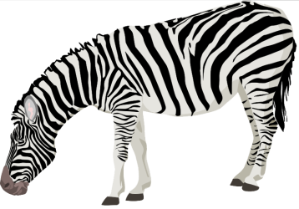
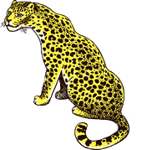
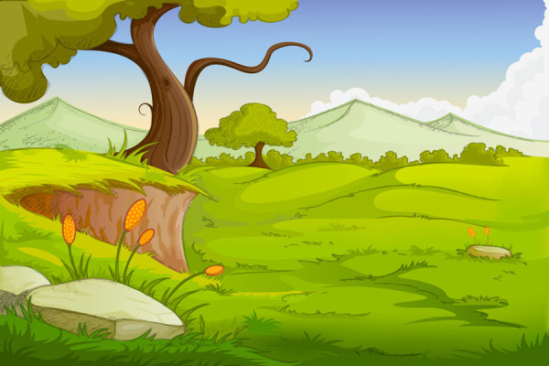
_______________________________________________________________________________
_______________________________________________________________________________
_______________________________________________________________________________
_______________________________________________________________________________
Napiš 4 věty o obrázku. Použij There is, there are …
_______________________________________________________________________________
_______________________________________________________________________________
_______________________________________________________________________________

