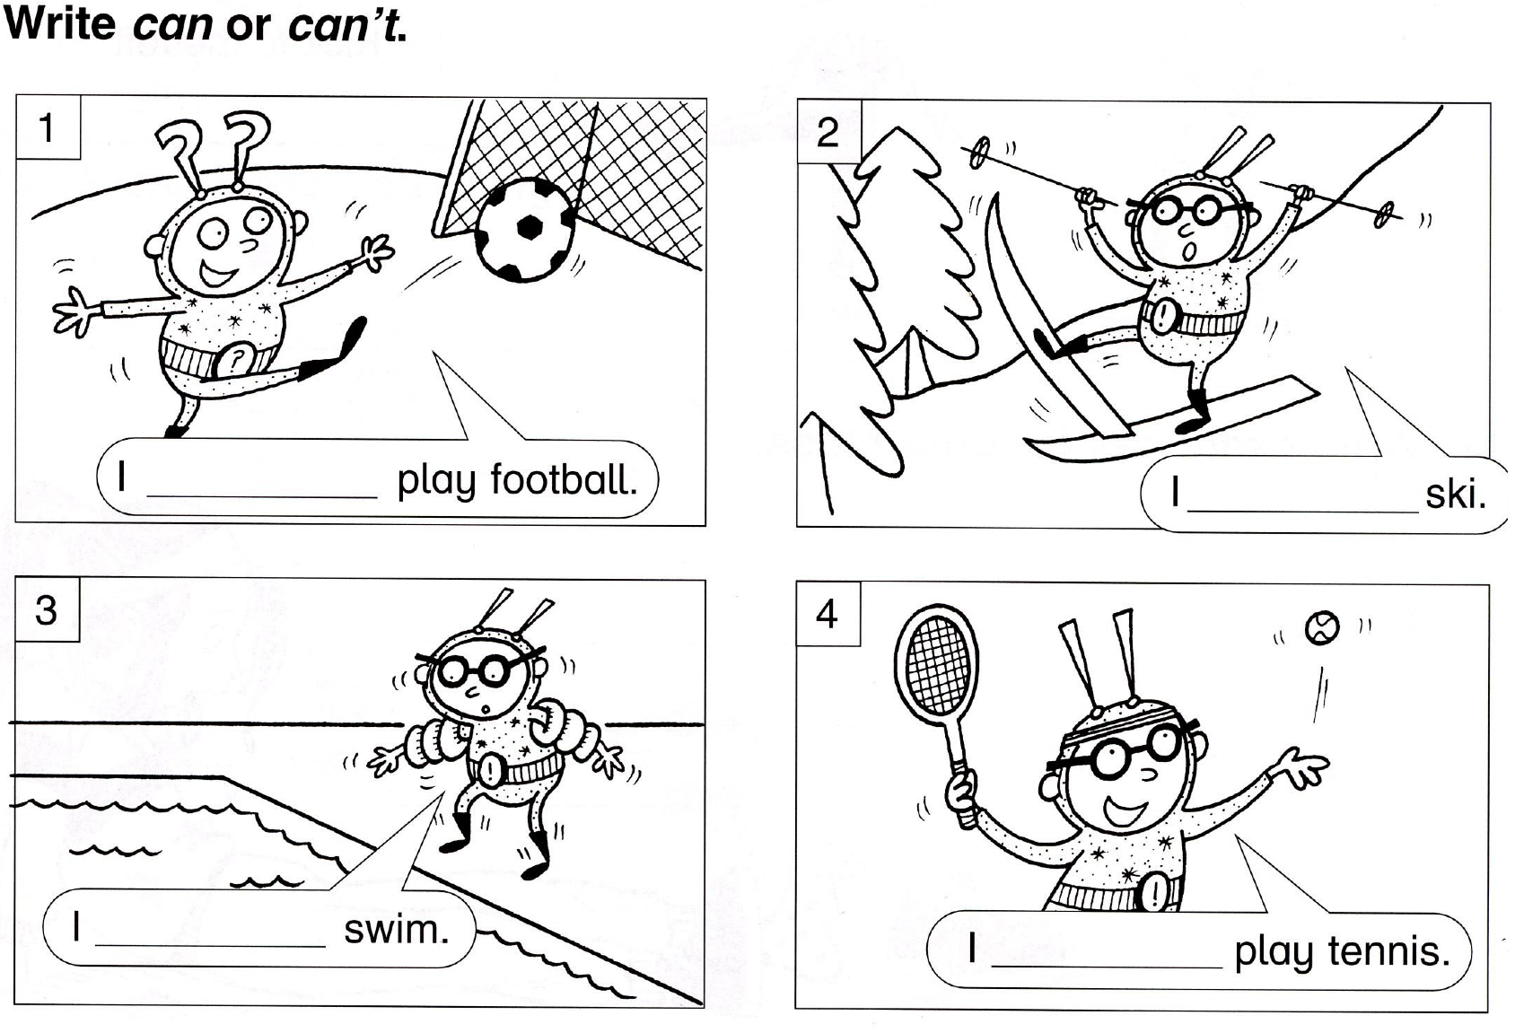

Napiš krátké odpovědi
Y = yes N = no
1. Is he a football player? (N) __________________________.
2. Can he play football? (Y) __________________________.
3. Can he ski? (N) __________________________.
4. Is he happy on skis? (N) __________________________.
5. Is he your friend? (N) __________________________.
6. Can he swim? (N) __________________________.
7. Can he play tennis? (Y) __________________________.
8. Is he smiling? (Y) __________________________.

